Plants
- Eukaryotic
- Cell walls with ________________
- Multicellular
- Autotrophic – Photosynthetic
- Mostly ___________ reproduction (pollen and eggs)
- Some ___________ reproduction (vegetative propagation)
- Can be non-vascular (no transport system) or vascular (transport system)
- Vascular have ___________ (carry water) and ______________ (carry nutrients) – most plants
- Non-vascular transport ________________ and nutrients from cell to cell by _____________ and diffusion – mosses
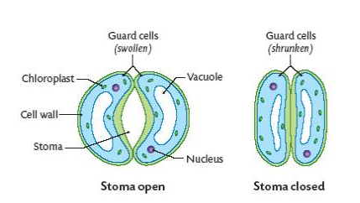
Non-Vascular Plants
- Lack __________________ tissue
- Ex: ferns, mosses, and liverworts
- Have sperm and egg on separate structures

Vascular Plants
- Xylem – transports water
- Phloem – transports nutrients (sugar)
- Special openings in surface = _______________
- Formed by two ___________ __________

Gymnosperms
- ____________ plant – have xylem and phloem
- Gymnosperm means “___________ seed”
- Their seeds are __________ protected by any outer covering
- Seeds are produced on the outside of ______________
- Gymnosperms include conifers (pine trees and spruce trees)
- Most pollination is caused by the __________
- Gymnosperms produce _________ in male cones which fertilizes _____ in female cones
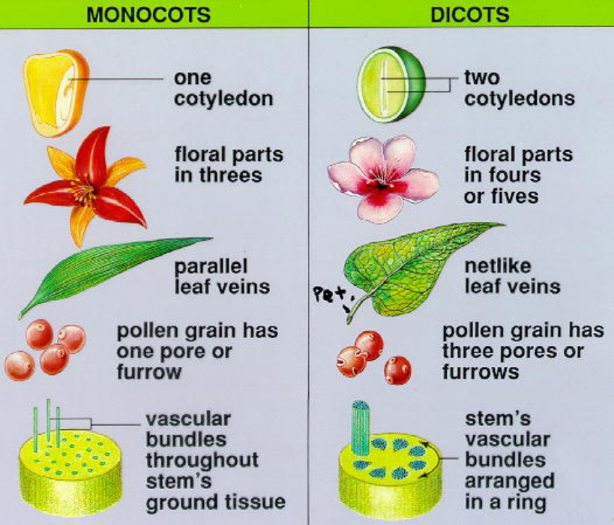
Angiosperms
- __________________ plant – have xylem and phloem
- Angiosperm means “____________ seed”
- Their seeds are protected by ovaries - which surround the seed and mature into ________
- Angiosperms also produce ______________ - which attract pollinators
- Pollination is caused by insects or birds that transfer ___________ from one flower to another
- Most plants are ________________________
- Angiosperms can be ________________ (one cotyledon) or ________________ (two cotyledons) – chart on page 570
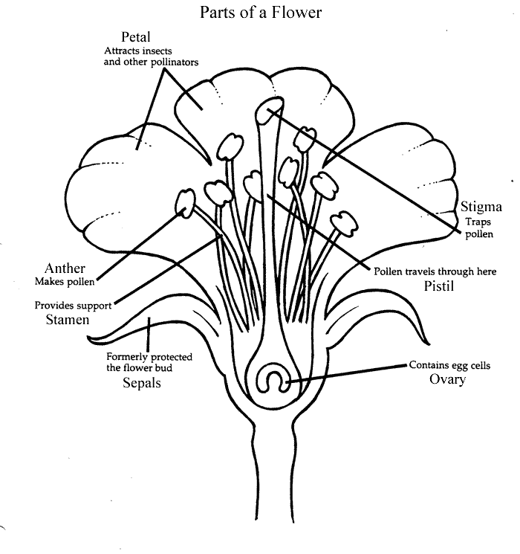
- Think of a girl named Angie – girls like flowers
- Reproduction:
  - ________ = male reproductive structure
    - anther (produces pollen containing sperm)
    - filament
  - __________/carpel = female reproductive structure
    - Stigma (sticky and collects pollen)
    - Style
    - Ovary (holds ovules containing eggs)
  - ___________________ = pollen is transferred to the stigma
  - ___________________ = pollen reaches and fuses with egg
  - The fertilized egg becomes a ____________
  - As the seed forms, the ovary swells and ripens to form __________ (aids in dispersal of seeds)

Tropisms
- Plant growth responses to external stimuli
- Examples:
- _________________ = response to light
- ____________________ = response to gravity (roots grow toward gravity; stems grow against it)
- ____________________ = response to contact (vine)

Plant Regulation
- Plants produce ______________ which regulate their growth and development and may control responses to stimuli
- Examples:
- ________________ = allow for elongation of the cell; allows the plant to bend
- ________________ = promote rapid cell division
- ________________ = promotes fruit ripening

Practice EOC Questions – Goal 2.1.2
- Which of the plants in the chart below is most likely a gymnosperm?
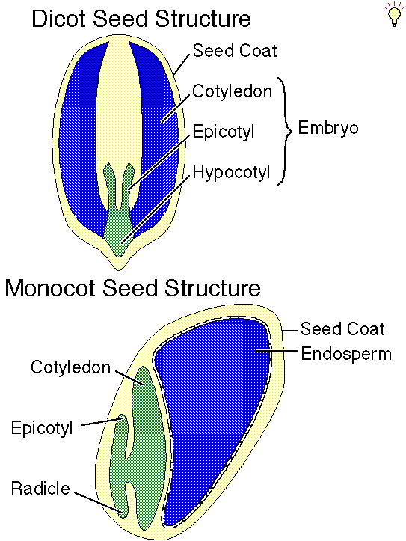
 | Vascular Tissue | Seeds | Flowers | Cones
Plant A | X | X |  | X
Plant B | X
Plant C
Plant D | X | X | X

- How would the seeds in the diagram below be classified?
A. Ferns B. Mosses C. Angiosperms D. Gymnosperms
- If the xylem in a young tree is damaged, which process is first affected?
A. performing photosynthesis B. transporting sugar to the roots
C. transporting water to the leaves D. absorbing water from the soil
- A plant species lives in an area with limited sunlight. Which physical adaptation would be most useful to the plant?
A. colorful flowers B. large leaves C. deep roots D. thin cuticle
- What is the main function of leaves?
A. leaves provide support for growth and a place to store food
B. leaves provide a place for photosynthesis to occur
C. leaves absorb water and minerals and transport nutrients to the stem
D. leaves create a barrier that prevents water in the plant’s tissues from evaporating
- What is the most likely function of a group of cells that contains a high number of chloroplasts?
A. respiration B. transpiration C. fermentation D. photosynthesis
- Which kingdoms have photosynthetic organisms?
A. fungi and plants B. fungi and protists C. protists and plants D. plants and animals
- Which structure in the leaf controls the opening and closing of the stoma?
- Cuticle B. epidermis C. guard cell D. spongy mesophyll

Describe the functions of…
- Xylem ______________________________________
- Phloem ____________________________________
Phototropism: | Thigmotropism: | Gravitropism:
Draw it! | Draw it! | Draw it!

List the plant adaptation for each scenario:
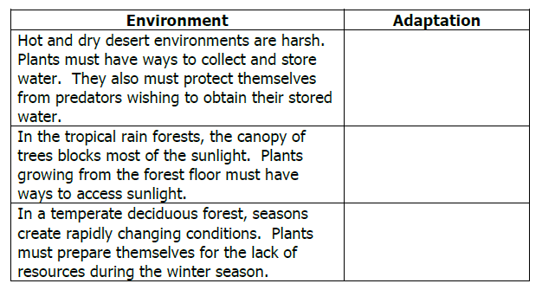

Label AND define the functions of each of the numbered items:
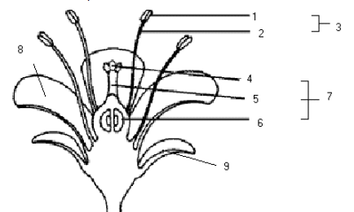

1.________________: _____________________________________________________
2.________________: _____________________________________________________
3.________________: _____________________________________________________
4.________________: _____________________________________________________
5.________________: _____________________________________________________
6.________________: _____________________________________________________
7.________________: _____________________________________________________
8.________________: _____________________________________________________
9.________________: ____________________________________________________

Animals
Multicellular, ___________________, heterotrophs with NO cell ___________

- Invertebrates (_______ a backbone) – 95% of all animals
  - Ex: sponges, jellyfish, worms, insects, crustaceans, spiders, and starfish
- Vertebrates (have a ____________________)
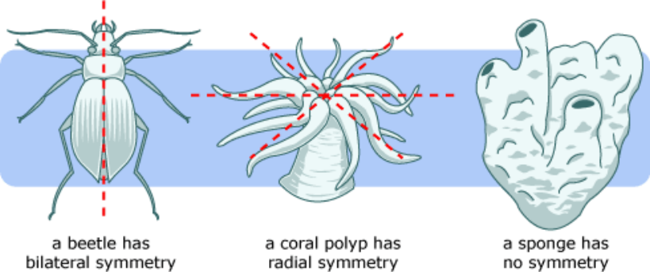
  - Ex: fish, amphibians, reptiles, birds, mammals
- Symmetry = whether one half of the animal matches the other half
  - ________________ - does not match (sponge)
  - ________________ - matches many ways (jellyfish)
  - ________________ - matches one way
- Segmentation – division of some animals into ___________________ parts (ex: earthworm)
- Cephalization – concentration of sense organs in a ____________ region

- STERNGRR:
  - _______________ - how organisms build necessary molecules
    - Protein synthesis – ribosomes are used to make proteins from amino acids based on DNA code
    - Lipid synthesis – the ER produces lipids like phospholipids for cell membranes
  - _______________ - how organisms get what they need to cells; move wastes
    - Blood cells carry nutrients and oxygen to cells and carry waste products away from those cells
  - _______________ - how organisms get rid of their waste and balance their fluids
    - Invertebrates → have specialized structures to filter waste from blood; _______________ in annelids and ____________________________ in insects
    - Vertebrates → use _____________ that are made up of nephrons to filter wastes
  - _______________ - how organisms get oxygen from the environment and release carbon dioxide back to the environment
    - Worms → oxygen can diffuse through moist ________ and enter bloodstream; large __________________________ to body volume helps increase diffusion
    - Aquatic invertebrates and vertebrates → use _________ to allow diffusion of oxygen from water into bloodstream
    - Terrestrial invertebrates → rely on _______ with alveoli (allow for fast diffusion of oxygen into blood and carbon dioxide out of blood)

  - _______________ - how organisms break down and absorb food
    - Insects have chewing mouthparts called _______________
    - Vertebrates have teeth
    - Digestive tracts include an esophagus, stomach, and intestines
    - _______________ - fingerlike projections that line the intestines and increase _____________________________
  - _______________ - sexual verses asexual types of fertilization
    - Sponges – fragmentation
    - Starfish - ____________________
    - Animals around water → _____________ fertilization (females lay eggs and males fertilize outside the body)
    - Land animals → _____________ fertilization
  - __________ and _________________ - metamorphosis, development in egg or in uterus
    - Insects and amphibians → undergo metamorphosis
      - ________________ metamorphosis = egg → nymph → adult
      - ________________ metamorphosis = egg → larva → pupa → adult
    - Reptiles, birds, and mammals → called monotremes lay _______________ egg (protective enviroment for the embryo to develop on land without drying out)
    - Marsupials → develop in mother’s pouch
    - Most mammals develop in uterus of the mother; _______________ connects the embryo/fetus to the mother’s circulatory system
  - _______________ - control the body’s responses by responding to stimuli and maintains homeostasis
    - ______________ - basic unit of the nervous system (found in animals)
    - ______________ - part of the endocrine system (found in plants and animals)

A Neuron
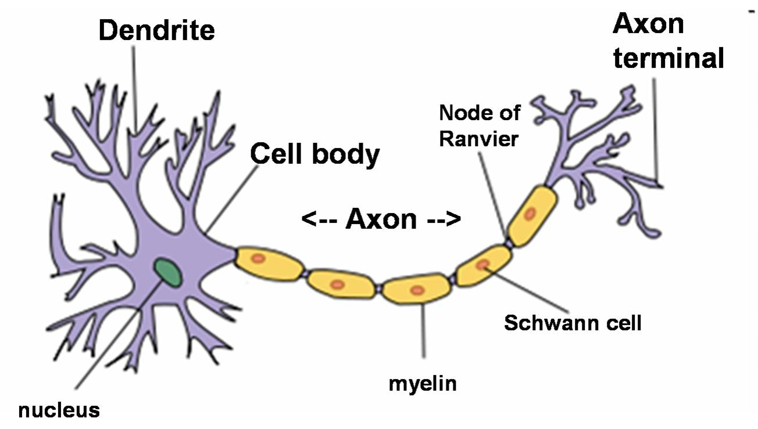

Practice Questions
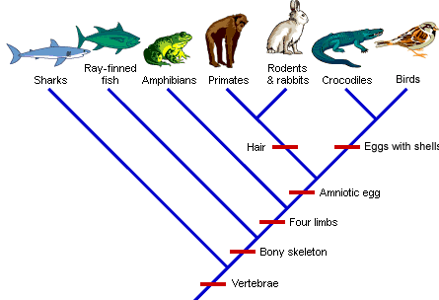

Characteristic | Sharks | Ray-Finned Fish | Amphibians | Primates | Rodents and Rabbits | Crocodiles | Birds
Vertebrae
Bony Skeleton
Four Limbs
Amniotic Egg
Hair
Eggs with Shells

1. The fertilized eggs of most mammals follow a similar pattern of early development. Which sequence is the typical pattern, beginning with the earliest stage?
A. fetus → embryo → zygote B. fetus → zygote → embryo C. zygote → fetus → embryo D. zygote → embryo → fetus

2. Which reproductive adaptation is more characteristic of mammals than amphibians?
A. external fertilization with internal development B. internal fertilization with internal development
C. external fertilization with external development D. internal fertilization with external development

3. Which group of mammals lay eggs? A. placentals B. monotremes C. marsupials D. umbilicals

4. Through which structure do developing embryos receive nourishment from their mothers?
A. placenta B. mammary glands C. egg D. diaphragm

5. What adaptation enables animals to reproduce successfully on land?
A. internal fertilization B. egg cells released from ovaries
C. fertilization outside the body of the female D. diploid gametes that undergo differentiation

6. Sandworms are annelid worms that live on the seafloor. They absorb oxygen and excrete wastes through their skin. Which characteristic will best help the worm carry out these functions?
A. large number of hearts B. large diameter blood vessels
C. large mouth compared to body volume D. large surface area compared to body volume

7. The structure of the digestive tube in the grasshopper and earthworm consists of many folds. The folds affect the efficiency of food absorption by which of the following functions?
A. increasing surface area B. reducing transpiration C. increasing hormone secretion D. reducing storage of sugars
Behavior Notes
- Behavior = the way an organism reacts to __________ in its internal or external ______________
- Stimulus = a _____________ that informs an organism of some condition in their environment
- Response = an organism’s ____________ to a _______________ (low blood sugar → release of insulin → triggers hunger)
- Learned Behavior = _________________ during an organism’s life; may change with practice or ________________
- Instinct/Innate Behavior = ___________ behavior
Innate Behaviors
- ________________ Response = quick, unconscious reactions
  - Ex: reflexes
- ______________________ Response = body’s response to stress or fear
  - Ex: increased heart rate in an accident
- ________________ = complex, innate behaviors (urges)
- __________________ = allows animals to feed right after birth
- __________________ Behavior = pre-mating behavior designed to help an organism recognize and pick the “best” mate
- __________________ = defending physical space against animals; reduces competition for scarce resources
Ex: cat scent marks its territory to warn others
- ________________ = a threatening behavior that one animal uses to gain control over another
- ________________ _______________ = a social ranking, within a group, that establishes dominant and submissive members
- Ex: a puppy rolls over and exposes its belly to adult dogs
- ________________ Behaviors = animals display TAXIS behaviors; movement _____________ or __________ from a stimulus
- ________________ = movement in response to __________
Ex: moths are attracted to light (positive)
- _______________ = movement in response to _____________
Ex: insects attracted to chemical signals from other insects (positive)
Behavioral Cycles (Biological “Clocks”) = animals respond to ________________ changes in the __________________ with daily or seasonal cycles of behavior
- ________________ Rhythms = daily cycles of behavior
Ex: sleeping and waking
- __________________ Rhythms = occur at certain times of the year
- ________________________ = movement from one place to another and back again in response to environmental stimuli
- ____________________ = a decrease in metabolism in response to ___________ temperatures
- ____________________ = a decrease in metabolism in response to ___________ temperatures
Learned Behaviors are present in mostly in animals with highly developed nervous systems
Requires __________________ (an internal need that causes an animal to act – ex: hunger)
- ________________ = occurs when an animal is repeatedly given a stimulus with no punishment or reward; they eventually stop responding
Ex: sleeping through the night even if a train is close by to your house
- ___________ Learning/ _______________ = most complicated form; animal applies something it has learned to a new situation
Ex: pianist plays a new piece of music by “ear”
- _____________ _____________________ = occurs when an animal makes a ______________ between a __________________ and some kind of reward or punishment; “ learning by ______________________
Ex: Pavlov’s dogs – dog salivated when they heard bell
- _________________ ___________________ = occurs when an animal learns to behave a certain way through repeated _____________ in order to receive a reward or punishment; “trial by error”
Ex: mouse learns how to get through a maze to get food
_______________ behaviors = often combine learned and innate behaviors; animals interacting with members of their own species, include courtship, territoriality, dominance, hierarchy, and communication
- May form ________________ (a group of ______________ animals of the same species that interact closely and _________________ with one another)
Ex: zebras herd when grazing to confuse predators

____________________ = involves very young animals recognizing and following the first moving object they see
Ex: ducklings imprint on their mother

____________________ = involves the passing of information from one organism to another
Ex: innate forms may involve sound (whale’s song), sight (baring teeth), and touch (chimp grooming)
Ex: most complex form is ___________________

Goal 2.1.2 – Practice EOC Questions - Behavior
1. Which statement about animal behavior is most accurate?
A. innate behaviors can be changed as a result of individual experiences
B. innate behaviors are generally complex and require time to perfect
C. a complex nervous system is necessary for learned behavior
D. learned behaviors are acquired as a result of individual experience

2. In an experiment, Pavlov caused a dog to salivate when it heard the ring of a bell. Which type of learning was demonstrated by the dog? A. habituation B. imprinting C. conditioning D. trial and error

3. Which is an example of a learned behavior?
A. a bear cub practices catching salmon the way its mother does
B. a baby gazelle rises to its feet within a few minutes of its birth
C. a baby kangaroo climbs into its mother’s pouch as soon as it is born
D. an adult salmon returns to its freshwater stream when it is time to reproduce

4. When worker bees return to the hive, they perform a sequence of movements called a waggle dance to show other members of the colony where food is located. Which type of behavior does this best illustrate?
A. aggressive behavior B. courtship behavior C. social behavior D. territorial behavior

5. The males of a bird species do a “dance” and “sing a song” each spring. What is the main purpose of these behaviors?
A. to scare off young birds B. to imprint young birds C. to clean their feathers D. to attract female birds

6. At night, moths travel toward light. Which type of behavior does this describe?
A. habituation B. imprinting C. innate behavior D. learned behavior

7. Which is an example of a learned behavior?
A. A bear cub practices catching salmon the way its mother does.
B. A baby gazelle rises to its feet within a few minutes of its birth.
C. A baby kangaroo climbs into its mother’s pouch as soon as it is born.
D. An adult salmon returns to its freshwater stream when it is time to reproduce.

8. Which is an example of an innate behavior?
A. A bear cub practices catching salmon the way its mother does.
B. A mouse completes a maze faster over time
C. A baby kangaroo climbs into its mother’s pouch as soon as it is born.
D. A human trains a dog to sit using a treat.
9. Hibernation is a period of inactivity for animals experiencing conditions of extreme cold. Hibernation serves the same function as which activity practiced by animals in warm environmental conditions?
A. camouflage B. migration C. estivation D. mimicry

Behavior Matching Scenarios
Stimulus | Behavior | Estivation
Learning | Territoriality | Classical Conditioning
Trial and Error (Operant Cond.) | Imprinting | Reflexes
Circadian Rhythm | Communication | Courtship
Suckling | Habituation | Phototaxis
Hibernation | Innate Behavior | Chemotaxis

1. Skinner box: A mouse learns to press a lever by “trial and error” to receive a food reward

2. Any kind of signal that carries information and can be detected in the environment to which an animal responds

3. A male hamster releases a chemical message, to warn others of its species not to enter his territory

4. Animals can alter their behavior as a result of experience to enable them to adapt to their changing environment

5. Newborn babies know how to blink their eyes and to swallow based on instincts

6. A young child touches the hot stove and in milliseconds pulls back his hand before he is aware of the pain

7. Pavlov’s dog: A bell sounds and his dog begins to salivate even when no food is in his dish.

8. Movement in response to light ex: moths attracted to light

9. When an animal defends its area against other animals.

10. Certain species of flowers open their petals during the day and close their buds at night

11. The girl is no longer aware of her favorite necklace around her neck, which she put on an hour ago

12. A Japanese Crane dances by head bobbing, bowing, leaping, and short flights to identify a healthy mate from among the other flocks of birds at the water hole

13. The instinctive behavior of an animal that allows it to feed right after birth

14. Several baby chicks follow the mother duck to the nearby pond for a swim

15. Movement in response to chemicals (ex: insects attracted to chemicals from other insects)

16. An animal reaction to either internal or external conditions in the environment

17. A decrease in metabolism in response to colder temperatures.

18. A decrease in metabolism in response to warmer temperatures.

