**Evolutions Notes**

* ___________________________: life from living things
* 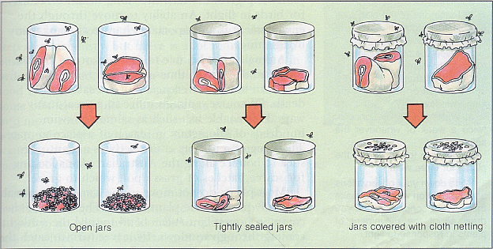___________________________: life from non-living things

__________________________ generation

**Who disproved spontaneous generation and how?**

1. ___________________________________:

* In 1668, used ____________ and _____________ in his experiment to show that flies did not come from meat but from ______________ (baby flies)

1. 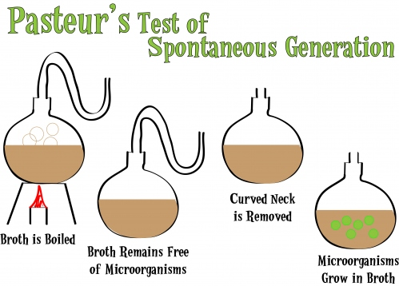___________________________________:

* Disproved spontaneous generation once and for all
* Filled S-shaped flasks with __________
* Boiled the broth to kill any microorganisms already in the broth and in the air
* Found no life after 1 year

**The Heterotroph Hypothesis**

* Early earth organisms:
  + ____________________: simple organisms
  + ____________________: no oxygen in atmosphere
  + ____________________: take in nutrients
* ______________________ hypothesis 🡪 symbiotic relationship between large and small cells developed
  + small cells became _______________________ and ___________________ with their own __________

**Natural Selection**

* + - Process:
* ______________ of traits leads to different phenotypes
* __________________ in populations leads to competition for resources
* ______________________ favors the best suited phenotype at the time
* _________________ of the best adapted (fittest) leads to higher reproductive success

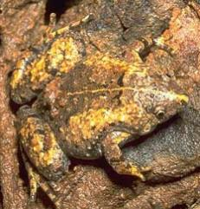**Adaptations**

* + Any _________________ trait that suits an organism to its natural function in the ___________________________ (niche)
  + ______________________ adaptations
* Mimicry and camouflage
  + ______________________ adaptations
* Herding, schooling, growling
  + ______________________ adaptations
* Enzymes, sight, oxygen-binding of hemoglobin

**3.4.2 – Mechanisms of Evolution**

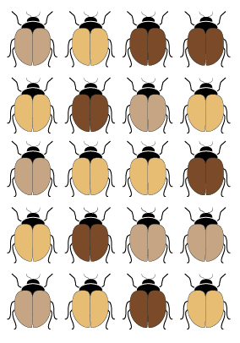

* Individuals don’t evolve; ______________________ do
* The population is the _______________ unit of evolution because acquired traits in an individual cannot be passed on (inherited by offspring)
* However, different traits already present in a population can be _________________, changing the population
* Evolution occurs when the _______________________ (all of the genes of a population) changes. A change may lead to a change in phenotype. Evolution acts on the phenotype

**Mutations**

* Mutations are random changes in DNA and may lead to a new phenotype. __________________ provide the raw material for evolution - _____________.
  + For example: a mutation causing white fur in Arctic foxes may lead to better camouflage in winter

----------------------------------------------------------------------------------------------------------------

**Selection**

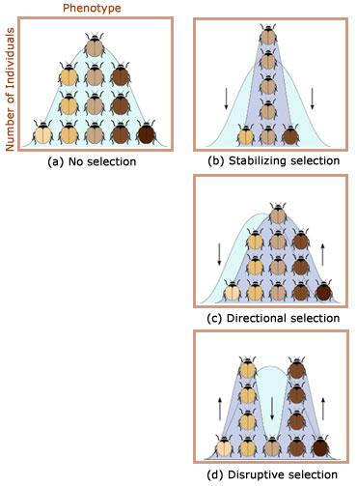The _________________ also plays a key role in evolution. Environmental changes are nature’s “selection forces” that act upon the ________________ ranges caused by genes. There are three basic patterns by which natural selection occurs:

1. ____________________ selection favors the _______________ phenotype in a population

2. ____________________ selection favors _________ of the extreme ends of the typical distribution

3. ____________________ selection favors ____________ of the extreme ends of the typical distribution

**Genetic Drift**

* Affects the genetic makeup of the population
* _____________
* Does not produce adaptations
* Most often occurs in _____________ populations

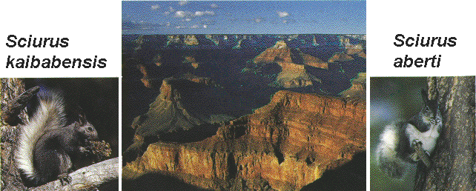**Speciation:**

* ______________________________ is the development of a new species.
* A ___________________ is defined as a group of organisms that can produce fertile offspring.
* Speciation occurs when a population is ___________________, usually due to a ______________________________________, and natural selection ________________ the population so much the two groups could no longer ______________________. Therefore, geographic isolation leads to _____________________ isolation.
* 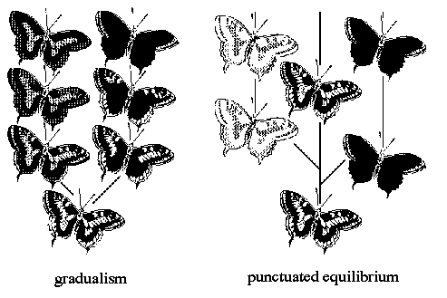Timeframes of evolution differ based on the environment and the population. The ___________________ provides evidence for two rates of speciation:

1. _____________________ describes speciation that occurs over a ________ period of time due to the accumulation of _____________ changes
2. ______________________________ describes speciation that occurs in ________________ that may be separated by 1000s of years of _______________. The primary stimulus is environmental change (ex: _______________)

**Co-Evolution**: The evolution of one species __________________ the evolution of the other species.

* *Example*: A moth and a flower. They evolve _________________ so the moth’s ____________ is exactly the right __________ to fit in the flower and eat the nectar, while pollinating the flower.
* *Example*: Garter snake and a rough-skinned newt: The snake eats the newt and the newt has developed ____________ to poison the snakes. Some snakes developed a mutation to be ________________ to the poison so they can still eat the newt

**3.4.1 = Evidence for Evolution**

|  |
| --- |
| 1. **Fossil Evidence:** ____________ are the ________________ or traces of organisms that once lived. Fossils show us that life went from simple to ____________, moved from ______ to land, and existed over ______________________ years ago.  * Many found in _________________ rock, which is formed from layers of slowly deposited sediments. * Two ways to date fossils:  1. ________________________ Dating: dating based on the observation that fossils in the   bottom= ___________, top = ______________   1. ________________________Dating: using ________________ isotopes to determine the **_________** age of a fossil. MUCH MORE _____________. |
| 1. **Anatomical:** comparing anatomical (__________) features between organisms, looking for evolutionary ______________________.  * _______________________ structures: have similar _____________ but different _______________. Organisms with similar bone structures may have evolved from a ______________ancestor.   Humerus..….………A Radius..…….……....B Ulna……...…….…….C Carpals…………...…D Metacarpals…..….E Phalanges………….F     * _________________ structures: have ________ function in present day organism, but was probably useful in its _____________.   + ***Examples***: human _______________ and the _________ bones of a whale. These structures provide further evidence of _______________ structure and function. |
| 1. **Biochemistry:** comparing _________ sequences between 2 different _____________      * **Example:** The table below indicates the number of amino acids that differ in the amino-acid sequence of the hemoglobin from selected organisms when compared to human hemoglobin. On the basis of this information, which organism would be classified as most closely related to humans?   ***Can use a ______________________________________!*** |

**3.4.3 - Examples of Evolution**

|  |
| --- |
| Antibiotic Resistance:   * antimicrobial__________________________ infections are treated with drugs known as __________________ * Some bacteria may have __________________ that make them resistant (______ _______) to the drug. * These bacteria survive and will go on to _____________________, so over time, the bacteria population will no longer ___________ if treated with an antibiotic |
| File:Pest resistance labelled light.svgPesticide Resistance:   * Pesticides are chemicals used to kill ______________ that harm crops * Occasionally, these insects develop ____________________ that make them resistant, allowing them to survive, reproduce, and pass their adaptation onto their offspring. |

**Dichotomous Keys**

* + - Sets of two (di=two) statements that can be used to identify organisms
* You simply read the statements until you determine what organism you are dealing with

**Example:**

|  |  |
| --- | --- |
| 1. a. Solid coat   b. Not solid coat | Go to 2  Go to 3 |
| 1. a. Smooth coat, long tail, no mane   b. Smooth coat with mane | *Felis concolor*  *Panthera leo* |
| 1. a. Striped   b. Spotted | *Panthera tigris*  *Acinonyx jubatus* |

The answer is ___________________________ which is the ____________!

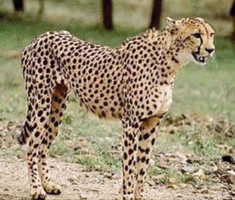

**Classification Practice EOC Questions – 3.5.1 and 3.5.2**

Use the Dichtomous key to identify the animal:

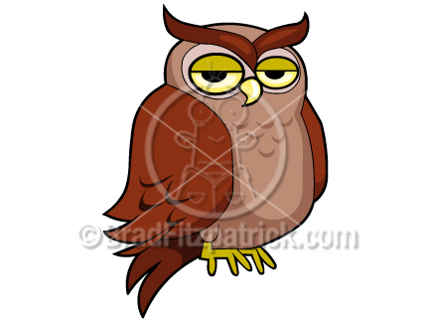1.a. Larger than 40. cm ……………....….2

1.b. Not larger than 40. cm ................ 4

*45cm*

2.a. Hooked beak…………………….….... 3

2.b. Beak not hooked.....Phasianus colchicus

3.a. Feathers over eyes that look like ear……Bubo virginianus

3.b. No Feathers that look like ears...Haliaeetus leucocephalus

4.a. Head one solid color of feathers............ 5

4.b. Head not solid color of feathers...... Colinus virginianus

5.a. Bill flat....................... Anas platyrhynchos

5.b. Bill pointed ............... Archilochus colubris

**Dichotomous Key**

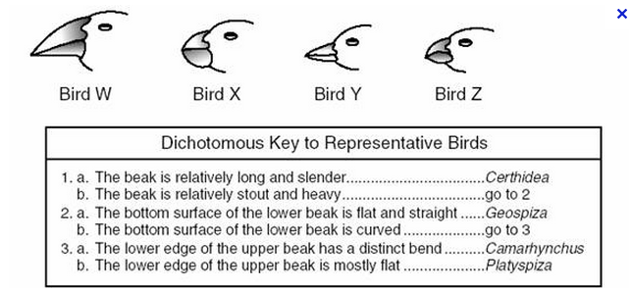

1. Bird W_________________
2. Bird X = _________________
3. Bird Y = _________________
4. Bird Z = _________________

|  |  |  |  |  |
| --- | --- | --- | --- | --- |
| 1. pami1 | 2. pami2 | 3. pami3 | 4. pami4 | 5. pami5 |
| 6. pami6  19 | 7. pami7 | 8. pami8 | 9. pami9 | 10. pami10 |
| 11. pami11 | 12. pami12 | 13. pami13 | 14. pami14 | 15. pami15 |
| 16. pami16 | 17. pami17 | 18. pami18 | 19. pami19 | 20. pami20 |

### 1. _________________________ 11. ___________________________

### 2. _________________________ 12. __________________________

### 3. _________________________ 13. __________________________

### 4. _________________________ 14. __________________________

### 5. _________________________ 15. __________________________

### 6. _________________________ 16. __________________________

### 7. _________________________ 17. __________________________

### 8. _________________________ 18. __________________________

### 9. _________________________ 19. __________________________

### 10. _________________________ 20. __________________________

## Taxonomy, Classification, and Dichotomous Keys

### Help! Scientists have discovered quite a few new creatures on planet Pamishan. They need your help to identify and classify them. Use the dichotomous key on the next page to identify these creatures

20

### A Key to New Pamishan Creatures

|  |  |
| --- | --- |
| 1. | a. The creature has a large wide head............................go to 2 |
|  | b. The creature has a small narrow head..........................go to 11 |
| 2. | a. It has 3 eyes ................................................go to 3 |
|  | b. It has 2 eyes ................................................go to 7 |
| 3. | a. There is a star in the middle of its chest....................go to 4 |
|  | b. There is no star in the middle of its chest ..................go to 6 |
| 4. | a. The creature has hair spikes .................................***Broadus hairus*** |
|  | b. The creature has no hair spikes...............................go to 5 |
| 5. | a. The bottom of the creature is arch-shaped ....................***Broadus archus*** |
|  | b. The bottom of the creature is M-shaped .......................***Broadus emmus*** |
| 6. | a. The creature has an arch-shaped bottom .......................***Broadus plainus*** |
|  | b. The creature has an M-shaped bottom...........................***Broadus tritops*** |
| 7. | a. The creature has hairy spikes ................................go to 8 |
|  | b. The creature has no spikes....................................go to 10 |
| 8. | a. There is a star in the middle of its body ....................***Broadus hairystarus*** |
|  | b. The is no star in the middle of its body .....................go to 9 |
| 9. | a. The creature has an arch shaped bottom .......................***Broadus hairyemmus*** |
|  | b. The creature has an M shaped bottum ..........................***Broadus kiferus*** |
| 10. | a. The body is symmetrical ......................................***Broadus walter*** |
|  | b. The body is not symmetrical...................................***Broadus anderson*** |
| 11. | a. The creatrue has no antennae .................................go to 12 |
|  | b. The creature has antennae ....................................go to 14 |
| 12. | a. There are spikes on the face .................................***Narrowus wolfus*** |
|  | b. There are no spikes on the face ..............................go to 13 |
| 13. | a. The creature has no spike anywhere ...........................***Narrowus blankus*** |
|  | b. There are spikes on the right leg ...........................***Narrowus starboardus*** |
| 14. | a. The creature has 2 eyes.......................................go to 15 |
|  | b. The creature has 1 eye........................................***Narrowus cyclops*** |
| 15. | a. The creature has a mouth......................................go to 16 |
|  | b. The creature has no mouth.....................................go to 17 |
| 16. | a. There are spikes on the left leg .............................***Narrowus portus*** |
|  | b. There are no spikes at all ...................................***Narrowus plainus*** |
| 17. | a. The creature has spikes ......................................go to 18 |
|  | b. The creature has no spikes ...................................***Narrowus georginia*** |
| 18. | a. There are spikes on the head .................................go to 19 |
|  | b. There are spikes on the right leg.............................***Narrowus montanian*** |
| 19. | a. There are spikes covering the face ...........................***Narrowus beardus*** |
|  | b. There are spikes only on the outside edge of head ............***Narrowus fuzzus*** |