**3.5.1 and 3.5.2 - Classification**

13

**The history & development of classification systems**

Aristotle began a simple _____________________________ system by grouping organisms into ____ main groups: ________________________ and ___________________________. These groups were called **kingdoms**.

**🡪 Can you think of any problems with this classification system?**

**Extension!**

Consider the organisms listed below. Based on your knowledge of plants and animals, which kingdom would they belong to? Plant or Animal?

|  |  |  |  |
| --- | --- | --- | --- |
| **Mold** | **Bacteria** | **Algae** | **Virus** |
|  |  |  |  |

People realized this problem! As a result, ________________________ systems are always ________________________ as we learn more about organisms. A scientist by the name of **Carrolus** **Linnaeus** developed the basis for today’s classification system.

**K =**

**P =**

**C =**

**O =**

**F =**

**G =**

**S =**

**Seven Level Classification System:**

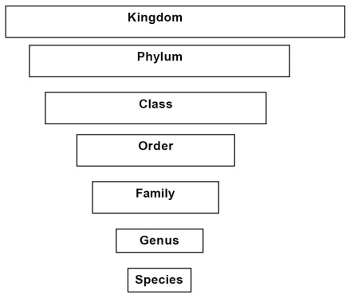

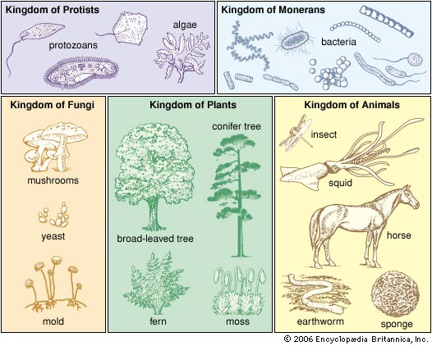

**Binomial Nomenclature**

This system was developed to prevent confusion when identifying animals and plants. The two parts of the name consists of the last two parts of Linnaeus’s system. This is __________________ and __________________. The language used is _______________________, because it is a universal language. The rules are simple.

**Steps:**

1. ___________________ name first, then ____________________ name.
2. _____________________ the genus name.
3. Write in _______________.

***Examples:***

14

***Dendrobates azureus Sarcorhamphus papa***

Species name = ___________________ Species name = ___________________

Genus name = _____________________ Genus name = _____________________

|  |  |  |  |  |
| --- | --- | --- | --- | --- |
| **Common name:** | **Human** | **Canadian Goose** | **Lake darner** | **Mosquito** |
| **Kingdom** | Animalia | Animalia | Animalia | Animalia |
| **Phylum** | Chordate | Chordate | Arthropoda | Arthropoda |
| **Class** | Mammalia | Aves | Insects | Insects |
| **Order** | Primate | Anseriformes | Odonate | Diptera |
| **Family** | Hominidae | Anatidae | Aeschnidae | Culicidae |
| **Genus** | Homo | Branta | Aeshna | Aedes |
| **Species** | Sapiens | Canadensis | Eremita | Fitchii |

1. Write the binomial scientific names of the species below:
   1. Canadian goose: _________________________________
   2. Mosquito: _________________________________________
   3. Human: ___________________________________________
   4. Lake darner: ______________________________________
2. Which two species are most closely related? (share the most taxons, or categories)

_____________________ & _____________________

**Phylogenetic Trees**

[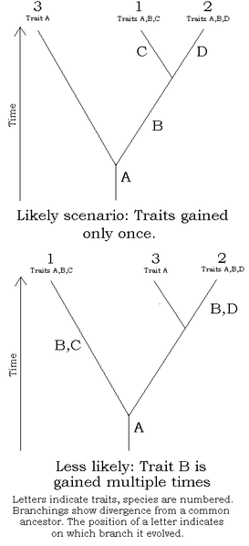](http://upload.wikimedia.org/wikipedia/en/1/13/Simple_cladistics.png)

The diagram to the right represents a

______________________ tree (also known as the

_______________ of ______________.

A phylogenetic tree shows a timeline of _______________________________ relationships.

1. Circle the common ancestor.
2. Write the letter of the organism that *evolved* first: _____
3. Write the letters of the two organisms that are most closely related: ______ and _____
4. Write the letters of the two organisms that share the greatest similarity in their DNA: _____ and _____
5. Write the letters of the two organisms that share the greatest number of amino acids: _____ and _____

**Dichotomous Keys**

* + - Sets of two (di=two) statements that can be used to identify organisms
* You simply read the statements until you determine what organism you are dealing with

**Example:**

|  |  |
| --- | --- |
| 1. a. Solid coat   b. Not solid coat | Go to 2  Go to 3 |
| 1. a. Smooth coat, long tail, no mane   b. Smooth coat with mane | *Felis concolor*  *Panthera leo* |
| 1. a. Striped   b. Spotted | *Panthera tigris*  *Acinonyx jubatus* |

The answer is ___________________________ which is the ____________!

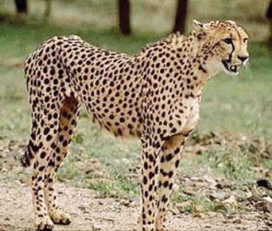

**Classification Practice EOC Questions – 3.5.1 and 3.5.2**

Use the Dichtomous key to identify the animal:

15

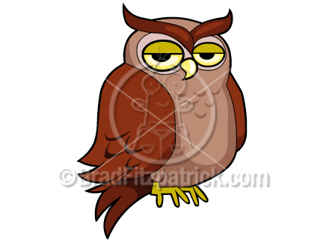1.a. Larger than 40. cm ……………....….2

1.b. Not larger than 40. cm ................ 4

*45cm*

2.a. Hooked beak…………………….….... 3

2.b. Beak not hooked.....Phasianus colchicus

3.a. Feathers over eyes that look like ear……Bubo virginianus

3.b. No Feathers that look like ears...Haliaeetus leucocephalus

4.a. Head one solid color of feathers............ 5

4.b. Head not solid color of feathers...... Colinus virginianus

5.a. Bill flat....................... Anas platyrhynchos

5.b. Bill pointed ............... Archilochus colubris

**1. What is the scientific name of the animal?**

A. Bubo virginianus B. Haliaeetus leucocephalus C. Colinus virginianus D. Anas platyrhynchos

**2. What kingdoms did Carolus Linnaeus originally use for his classification system?**

A. Fungi and Protista B. Fungi and Animalia C. Plantae and Protista D. Plantae and Animalia

**3. An organism is eukaryotic, multicellular, autotrophic, and has a cell wall. To which kingdom does it belong?**

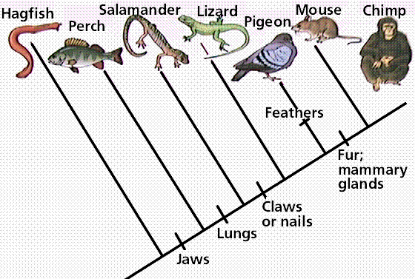A. Animal B. Fungi C. Plant D. Protist

**4. According to the cladogram, which animal is most closely related to the mouse?**

A. Salamander B. Perch C. Lizard D. Chimp

**5. Linnaeus divided his classification system for animals into 7 distinct categories. Which group orders the categories from least to most specific?**

A. Kingdom class phylum family order genus species

B. Kingdom phylum class order family genus species

C. Species family genus order phylum class kingdom

D. Species genus family order class phylum kingdom

**6. What is the difference between the full classification of organisms and their scientific names?**

A. The full classification of organisms and their scientific names vary in different countries.

B. The scientific names of organisms include the order and family of the organisms, but the full classification includes only the species name.

C. The full classification of organisms will include more categories of organisms than their scientific names.

D. The scientific names of organisms include a single nomenclature, but the full classification includes various nomenclatures.

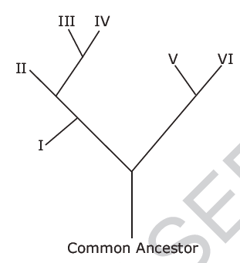**7. Which two species are the most closely related?**

A. I and II B. II and IV C. I and V D. V and VI

**8. Scientists use all of the following to create cladograms and classify animals except which method?**

A. Biochemical (DNA) B. Embryology C. Amino acid analysis D. Evolutionary Phylogeny

**9. A tree identification area on the school grounds was developed for biology classes. Which method of identification would use a series of questions comparing two traits about the tagged trees?**

A. a dichotomous key for trees B. a questionnaire on trees

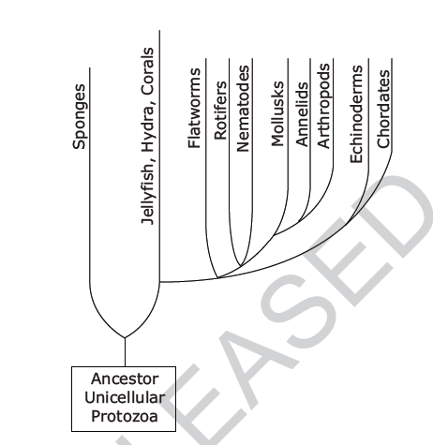C. a field guide to trees D. an Internet search on trees

**10. Which two groups of organisms have the most genetic differences?**

A. rotifers and nematodes B. mollusks and annelids

C. mollusks and chordates D. echinoderms and chordate

16

**Practice: Classification**

|  |  |
| --- | --- |
| **FLIP** | **FLOP** |
| Bacteria are unicellular organisms. They are prokaryotic and have thick cell walls. Some are autotrophs, while others are heterotrophs. There are so many bacteria in the world that Bacteria can receive their own domain. | How are Bacteria different from Eukarya? |
| After scientists established broad categories, they had to get more specific to describe ALL of the life on Earth. To do this, they developed a system called **Binomial Nomenclature**.  Bi=two and nom= name.  Essentially it means “Two names.”  The two names are its **GENUS** (Capitalized) and **SPECIES** (lower case). Both names are *italicized* if typed or underlined if written by hand.  **Example**: *Homo sapiens* is the name for humans  *Canus lupus* is the name for wolves | In the following binomial names, CIRCLE the GENUS. Then UNDERLINE the species.  *Felis domesticus* (house cat)  *Taraxacum officnale* (dandelion)  *Tyrannosaurus rex* (T rex dinosaur)  *Mus musculus* (mouse)  How should someone correct this name to make it consistent with binomial nomenclature?:  troglodytes aedon |
| As new technologies develop, scientists can more accurately classify organisms. This system is always changing because we always get new information!  New technologies that help us expand our knowledge include:   1. Similarity of **genes** (Chromosomes) 2. **Biochemistry** (DNA or amino acid sequences) 3. **Embryology**: Closely related species look similar as embryos 4. **Morphology**: Shared structure= closely related 5. **Phylogeny**: grouped according to how close they are related evolutionarily | How are evolution and classification dependent on each other?  With what information can we conclude that organisms evolved from a common ancestor?  What is phylogeny? *OWN WORDS!* |

**Reflect**…

1. If viruses are not considered living, do you think they are assigned a place in this classification system? Why or why not?
2. Of the following organisms, circle the one that is least like the other two:

*Canis familiaris Canis lupus Felis domesticus*

1. Number the eight classification groups in order from the group that contains the most closely related organisms (1) to the group with the least closely related organisms (8)

____ class ____ family ____ genus ____ kingdom

____ order ____ phylum ____ species ____ domain

1. If your name was a scientific name, which part would be the genus? ____________ Which part would be the species? _______________

Classification Activities – 3.5.1 and 3.5.2

**Part 1 – Read the Charts and Answer the Questions**

|  |  |  |  |  |  |  |
| --- | --- | --- | --- | --- | --- | --- |
|  | **House Cat** | **Red Fox** | **Dog** | **Wolf** | **Gopher** | **Fly** |
| **Kingdom** | Animalia | Animalia | Animalia | Animalia | Animalia | Animalia |
| **Phylum** | Chordata | Chordata | Chordata | Chordata | Chordata | Arthropoda |
| **Class** | Mammalia | Mammalia | Mammalia | Mammalia | Mammalia | Insecta |
| **Order** | Carnivora | Carnivora | Carnivora | Carnivora | Rodentia | Diptera |
| **Family** | Felidae | Canidae | Canidae | Canidae | Geomyidae | Muscidae |
| **Genus** | *Felis* | *Vulpes* | *Canis* | *Canis* | *Thomomys* | *Musca* |
| **Species** | *domesticus* | *fulva* | *familiaris* | *lupus* | *bottae* | *domestica* |

1. List the 7 classification categories, in order, from the most general to the most specific.

2. Which organisms are most closely related?

3. Which organisms are the least closely related?

4. What does binomial nomenclature mean? Give an example from above.

5. What type of writing is used when utilizing binomial nomenclature?

6. What is the genus and species name for a human?

7. *Vulpes fulva* belongs to which family?

8. What is the taxonomic designation of the fly?

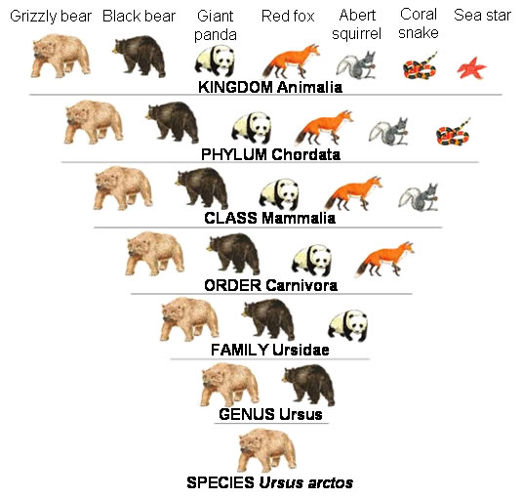

17

1. Which animal is the Grizzly Bear least related to?
2. Which animal is the Grizzly Bear most closely related to?
3. What kingdom is the Grizzly Bear in?
4. What family is the Grizzly Bear in?
5. What is the binomial nomenclature for the Grizzly Bear?

**PART II – Read and Fill in the Cladogram**

Examine the sample cladogram, each letter on the diagram points to a derived character, or something different (or newer) than what was seen in previous groups. Match the letter to its character AND write the characteristics on the cladogram.

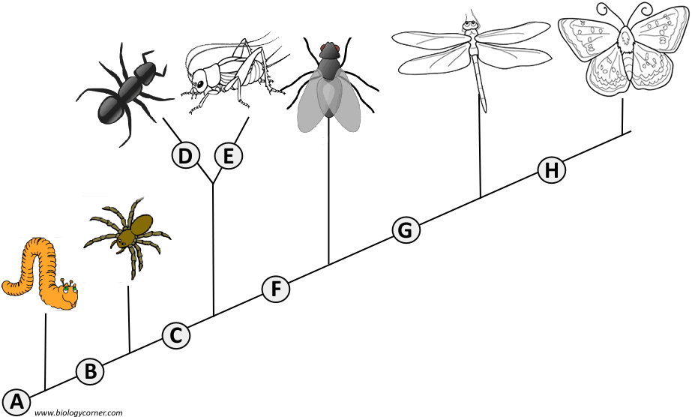

1. ______ Wings

2. ______ 6 Legs

3. ______ Segmented Body

4. ______ Double set of wings

5. ______ Jumping Legs

6. ______ Crushing mouthparts

7. ______ Legs

8. ______ Curly Antennae

1. Which 2 organisms are most closely related? Explain. __________________________________________________________________________________________

2. Which 2 organisms are least closely related? Explain.

__________________________________________________________________________________________

3. What characteristic makes the ant different from the grasshopper? _______________________________

18

**Part III – Dichotomous Key**

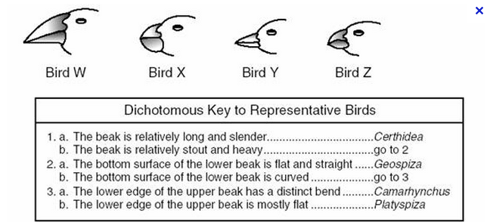

Bird W = _______________________

Bird X = ________________________

Bird Y = ________________________

Bird Z = _______________________